Name __________________________ Date_______________

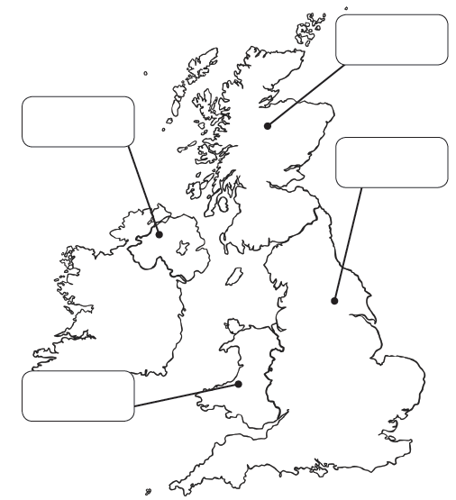T: Can I label the countries in the United Kingdom?

Label the countries of the United Kingdom.

Choose a different colour for each country and colour them in

*(colour the square below each name to match your colour choice)*

 England Scotland Wales Northern Ireland